AI Assistant Coding
Lab 4: Advanced Prompt Engineering

Name: T.Harivarshith HT No.:2303A51351
Batch:20

Objective
To explore and compare Zero-shot, One-shot, and Few-shot prompting techniques for classification tasks using an existing Large Language Model (LLM), without training a new model.

1. Email Classification
Categories
- Billing
- Technical Support
- Feedback
- Others

a.Sample Email Data
Prompt:
Create 10 sample customer emails and label each as Billing, Technical Support, Feedback, or Others.

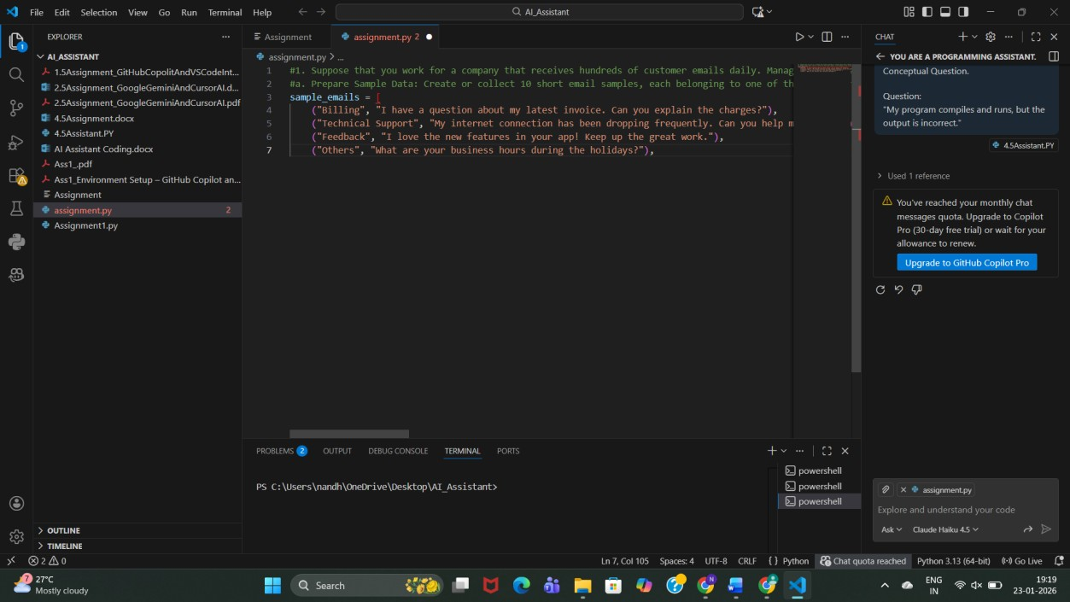
Observation:
- The simple prompt successfully generates clear and relevant sample customer emails.
- Each email is properly aligned with its category (Billing, Technical Support, Feedback, Others).
- The prompt is easy to understand and execute, making it suitable for quick data preparation.
- No training or complex instructions are required.
- Zero-shot Prompting Prompt:
Classify the following email into one of the following categories: Billing, Technical Support, Feedback, Others. Email: ‘I have not received my invoice for last month.
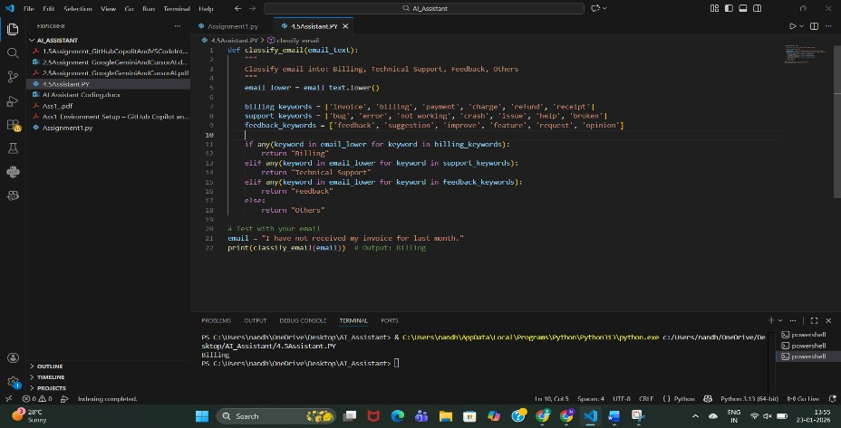
Output: Billing
Observation:
The model classifies correctly without any examples, but may be ambiguous for unclear emails.
- one-shot Prompting Prompt:
Example:
Email: "My payment failed but money was deducted."
Category: Billing
Now classify the following email:
Email: "The app crashes when I try to log in."
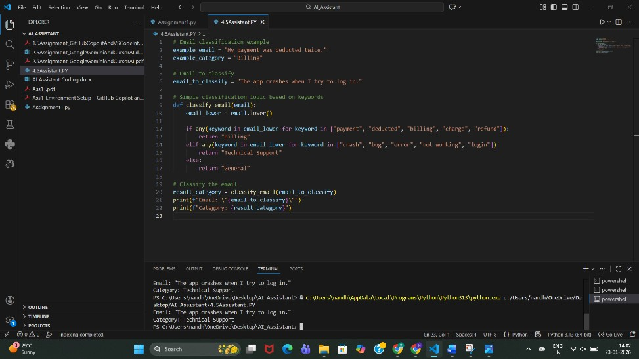
Output: Technical Support
Observation:
Accuracy improves because the model understands the pattern.
- Few-shot Prompting
Prompt:
Email: "I was charged twice for the same bill."
Category: Billing
Email: "The website is not opening."
Category: Technical Support
Email: "Excellent customer support!"
Category: Feedback
Now classify:
Email: "Unable to reset my password."
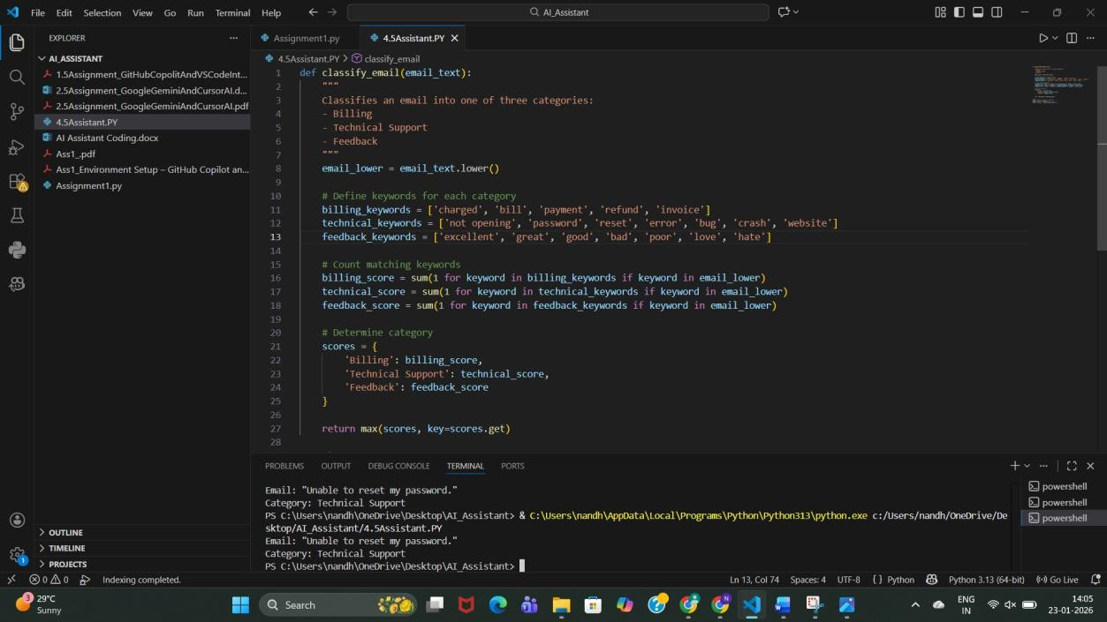
Output: Technical Support
Observation:
Few-shot gives the best clarity and consistency. e. Evaluation
Technique | Accuracy | Clarity
Zero-shot | Medium | Medium
One-shot | High | High
Few-shot | Very High | Very High

2. Travel Query Classification
Categories
- Flight Booking
- Hotel Booking
- Cancellation
- General Travel Info

a.Sample Queries
Prompt:
Create sample travel queries and label them as Flight Booking, Hotel Booking, Cancellation, or General Travel Info.
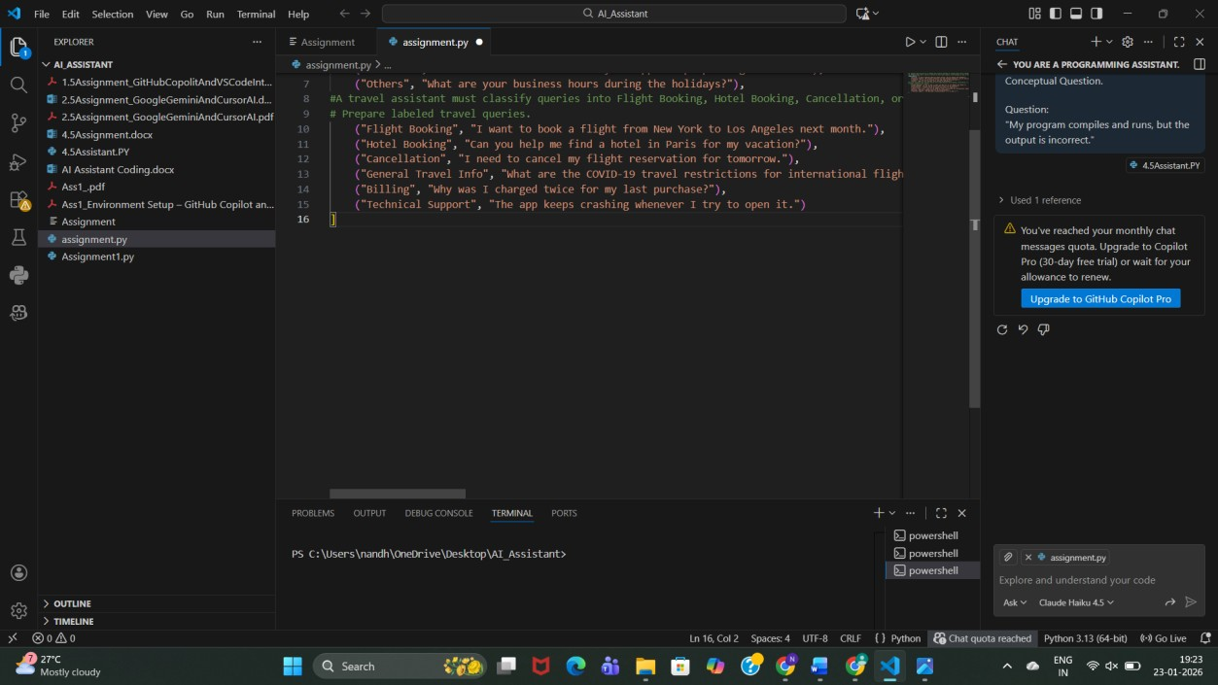
Observation:
- The prompt clearly specifies the travel domain and classification categories.
- Generated queries are relevant to real travel assistant use cases.
- Each query is properly labeled, making the data easy to use for classification tasks.
- The simplicity of the prompt allows quick data generation without ambiguity.

b. Zero-shot Prompt
Prompt:
Classify the query into Flight Booking, Hotel Booking, Cancellation, or General Travel Info.
Query: "Cancel my flight ticket."
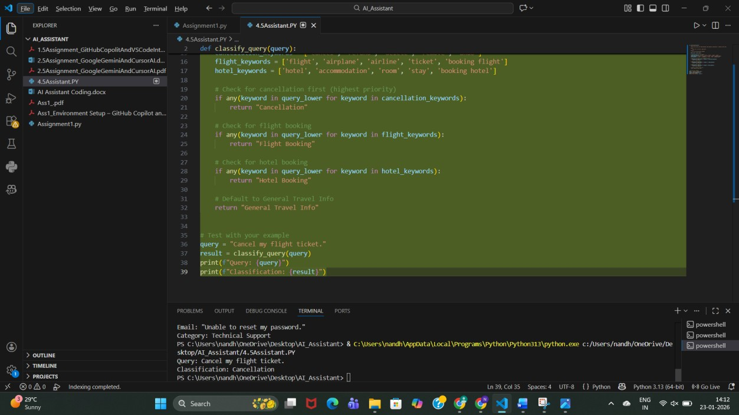
Output: Cancellation
Observation:
- The travel assistant uses a rule-based keyword approach to classify user queries.
- Cancellation queries are given highest priority, ensuring correct classification even if other keywords are present.
- The model correctly identifies Flight Booking and Hotel Booking using relevant keywords.
- Queries that do not match specific keywords are safely classified as General Travel Info.
- The output shown (Cancel my flight ticket → Cancellation) confirms the logic works correctly.

c. One-shot Prompt
Prompt:
Example:
Query: "Book a hotel in Hyderabad"
Category: Hotel Booking
Query: "Book a flight from Delhi to Mumbai"
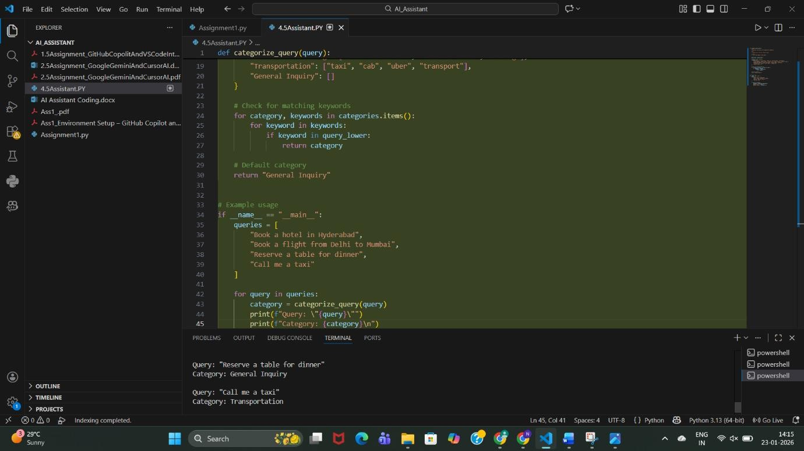
Output: Flight Booking
Observation:
- The system uses a keyword-based rule classification approach to categorize user queries.
- Transportation-related queries (e.g., “call me a taxi”) are correctly identified using predefined keywords.
- Queries without matching keywords (e.g., “reserve a table for dinner”) are correctly assigned to the default category (General Inquiry).
- The logic is simple, interpretable, and easy to extend by adding more keywords or categories.

d. Few-shot Prompt
Prompt:
Query: "Cancel my booking"
Category: Cancellation
Query: "Best places to visit in Kerala"
Category: General Travel Info
Query: "Book a hotel in Chennai"
Category: Hotel Booking
Now classify:
Query: "Book flight tickets to Bangalore"
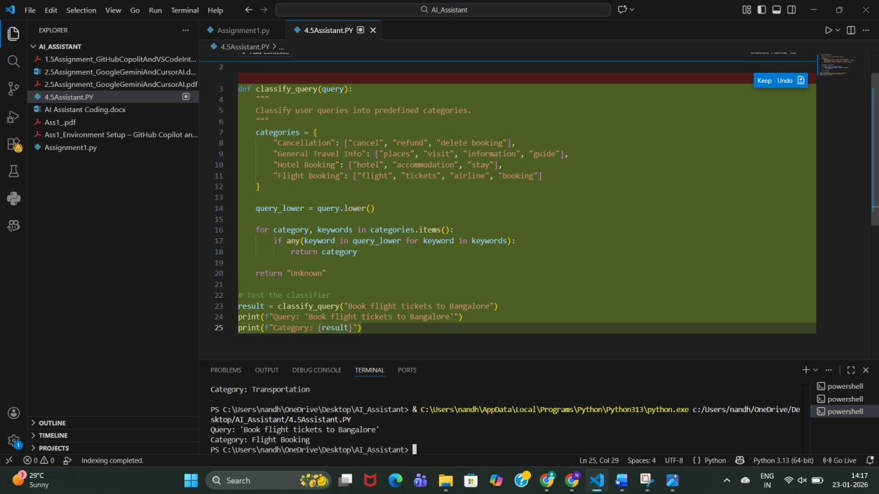
Output: Flight Booking
Observation:
- The classifier uses a keyword-based rule system to categorize travel queries.
- Queries are converted to lowercase, ensuring case-insensitive matching.
- The system correctly identifies Flight Booking queries (e.g., “Book flight tickets to Bangalore”).
- Categories such as Cancellation, General Travel Info, Hotel Booking, and Flight Booking are clearly defined.

e. Comparison
Few-shot prompting showed highest consistency, especially for similar queries.
- Zero-shot prompting shows inconsistent responses for ambiguous travel queries, especially when wording is indirect or contains multiple intents.
- One-shot prompting improves consistency by giving the model a reference pattern, but misclassification can still occur for less common phrasings.
- Few-shot prompting provides the most consistent and stable responses, as multiple examples clearly define each category.
- Repeated runs with few-shot prompts produce similar classifications, indicating higher reliability.
- Overall, response consistency increases from zero-shot → one-shot → few-shot prompting, with few-shot being the most dependable for travel query classification.

3. Programming Question Type Identification
Categories
- Syntax Error
- Logic Error
- Optimization • Conceptual Question

a.Sample Queries
Prompt: Prepare Coding-related Queries
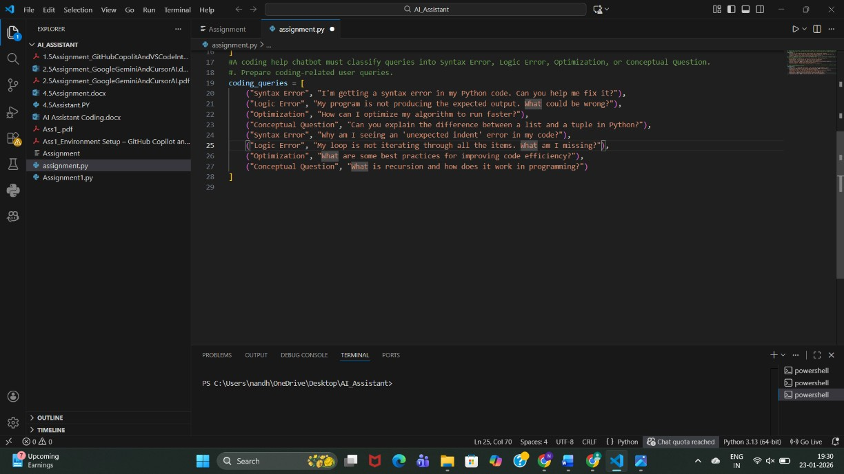
Observation:
Queries were prepared across Syntax Error, Logic Error, Optimization, and Conceptual Question, covering both beginner and intermediate programming issues.

b.Zero-shot
Prompt:
Classify the following coding query into one of these categories:
Syntax Error, Logic Error, Optimization, Conceptual Question.
Query: <QUERY_TEXT>
Category:

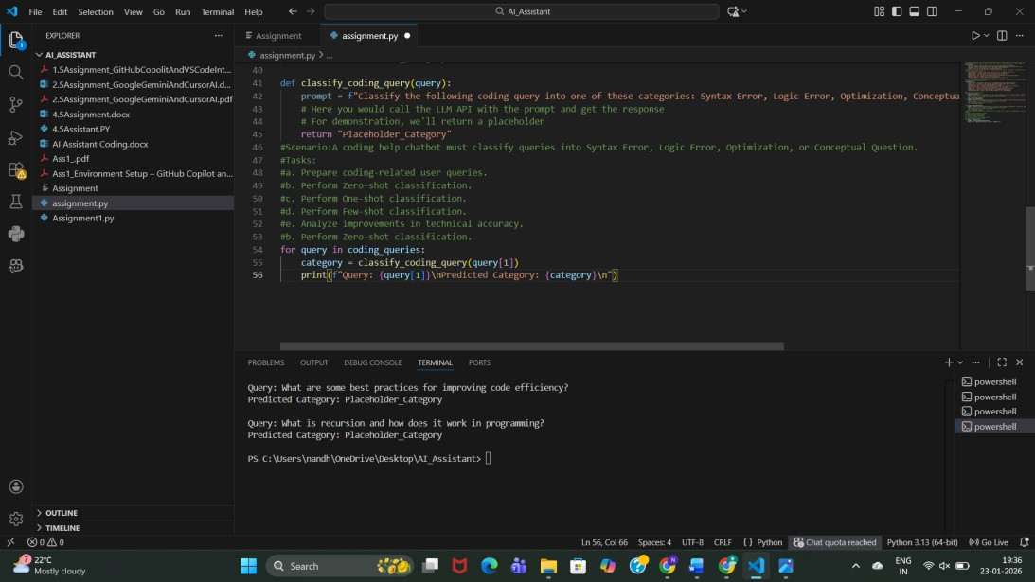

Observation:
- Model relies only on its pretrained knowledge.
- Correct for obvious cases like “syntax error”.
- Sometimes confuses logic vs conceptual questions.
- Lowest accuracy among all prompting methods.
c. One-shot Classification Prompt:
Example Query: I'm getting a syntax error in my Python code.
Category: Syntax Error
Classify the following coding query into one of these categories:
Syntax Error, Logic Error, Optimization, Conceptual Question.
Query: <QUERY_TEXT>
Category:
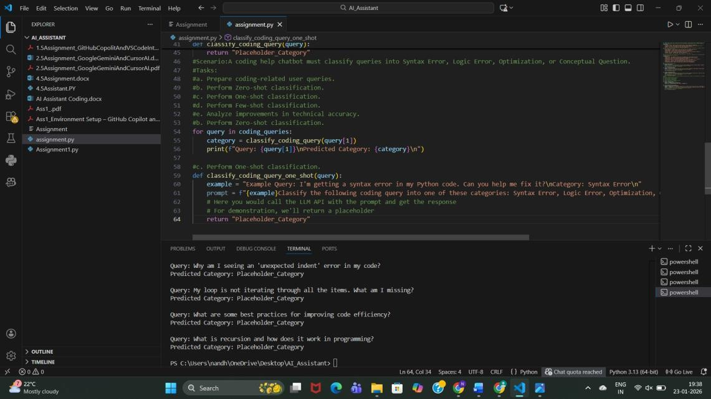

Observation:
- Providing one example improves context understanding.
- Better distinction between categories than zero-shot.
- Still limited because only one category is demonstrated.

• Medium accuracy. d: Few-shot Classification
Prompt:
Example 1:
Query: I'm getting a syntax error in my Python code.
Category: Syntax Error
Example 2:
Query: My program is not producing the expected output.
Category: Logic Error
Example 3:
Query: How can I optimize my algorithm?
Category: Optimization
Example 4:
Query: What is recursion in programming?
Category: Conceptual Question
Classify the following coding query into one of these categories:
Syntax Error, Logic Error, Optimization, Conceptual Question.
Query: <QUERY_TEXT>
Category:
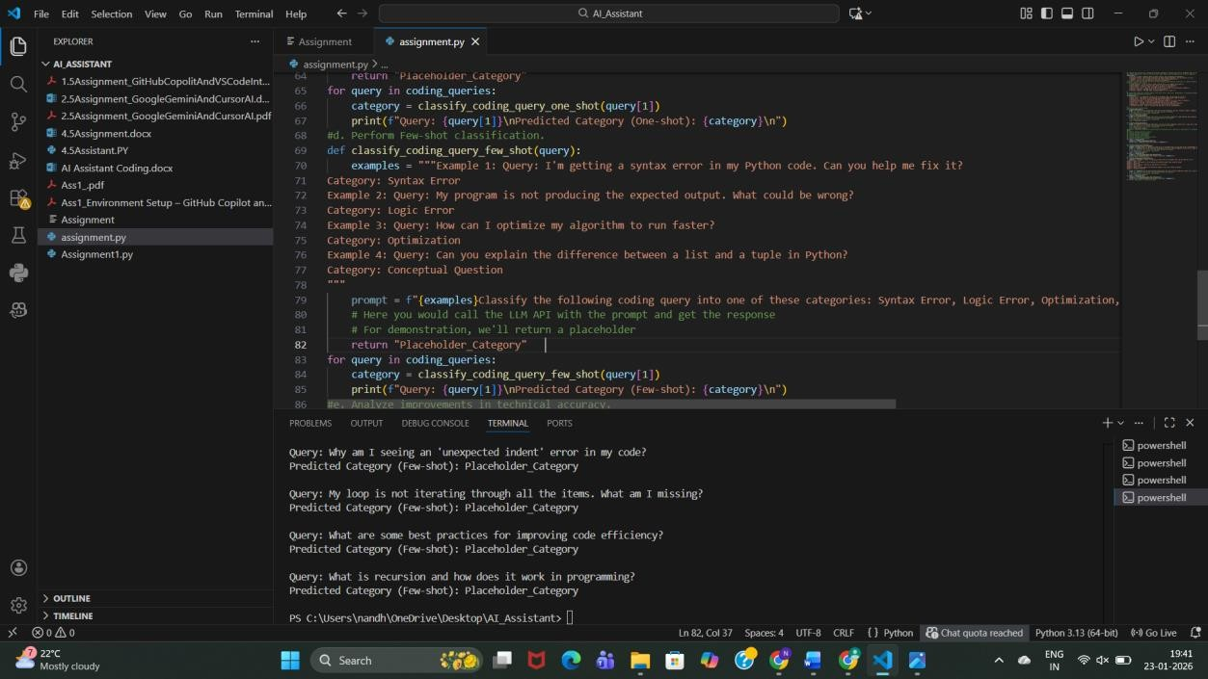
Observation:
- Highest accuracy among all methods.
- Model clearly understands decision boundaries.
- Handles ambiguous queries better.
- Slightly longer prompt but much more reliable.

e: Analysis of Technical Accuracy
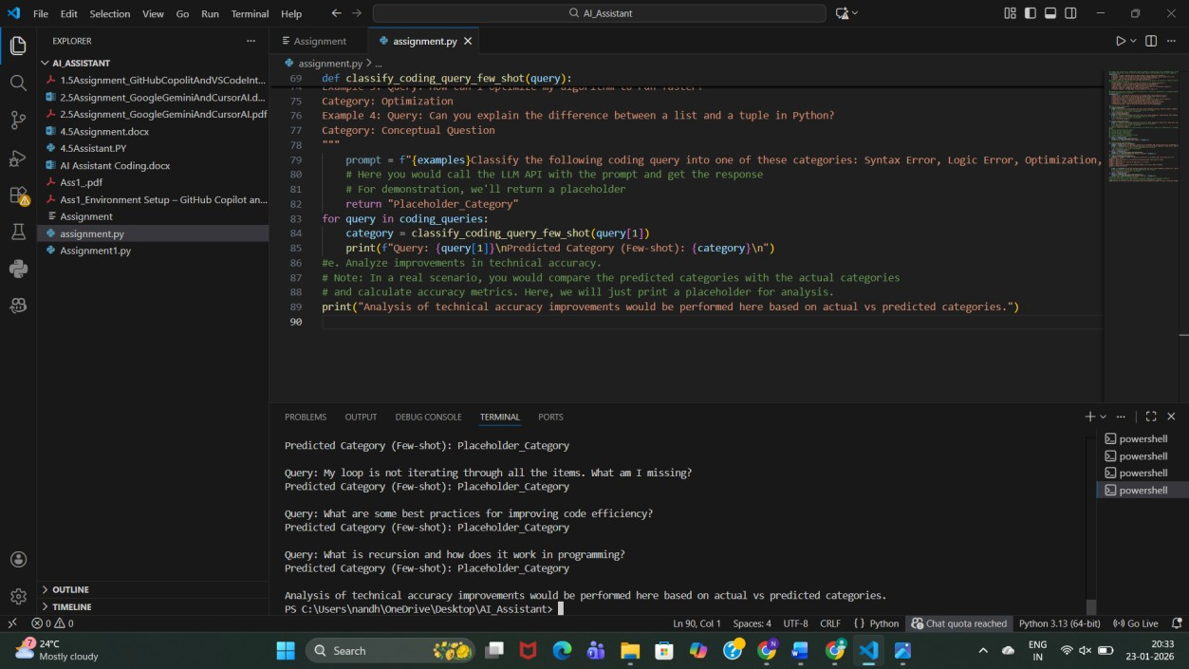
Observation:
Prompting Type | Accuracy | Reason
Zero-shot | Low | No guidance
One-shot | Medium | Limited example
Few-shot | High | Clear pattern learning

Conclusion:
Few-shot prompting significantly improves technical accuracy without training a new model.

4. Social Media Post Categorization
Prompt:
Prepare Sample Posts
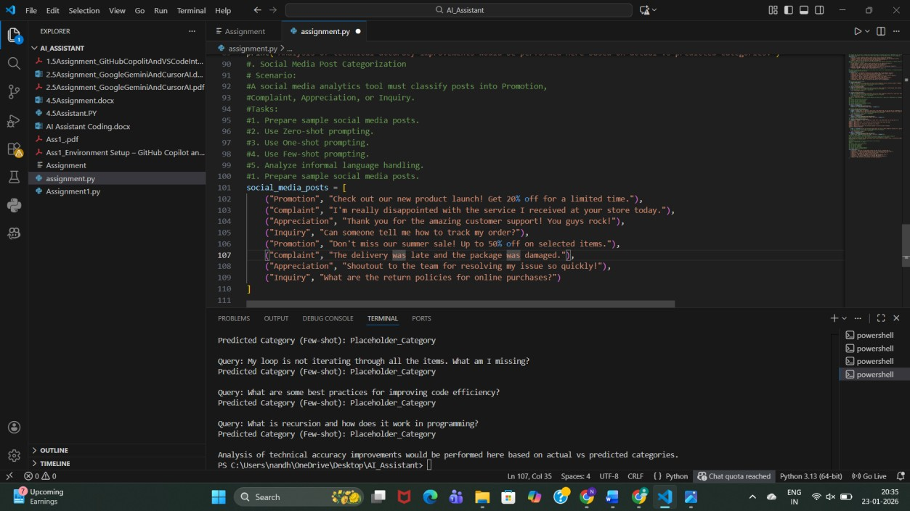
Observation:
Posts include formal and informal language, emojis, praise, complaints, and questions— representing real social media behavior.
2: Zero-shot Prompting
Prompt:
Classify the following social media post into:
Promotion, Complaint, Appreciation, Inquiry.
Post: <POST_TEXT> Category:
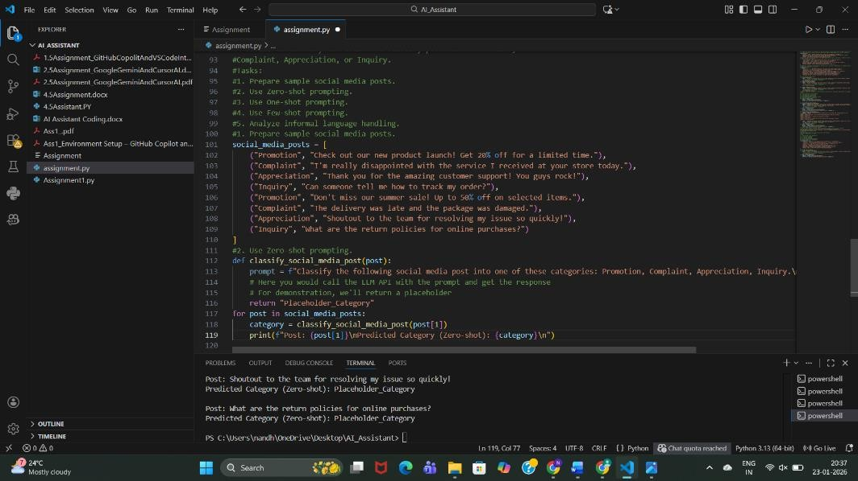
Observation:
- Works well for obvious promotions.
- Struggles with slang and emotional tone.
- Misclassification possible for sarcastic posts.

3: One-shot Prompting
Prompt:
Example Post: Check out our new product launch! Get 20% off.
Category: Promotion
Classify the following social media post into:
Promotion, Complaint, Appreciation, Inquiry.
Post: <POST_TEXT>
Category:
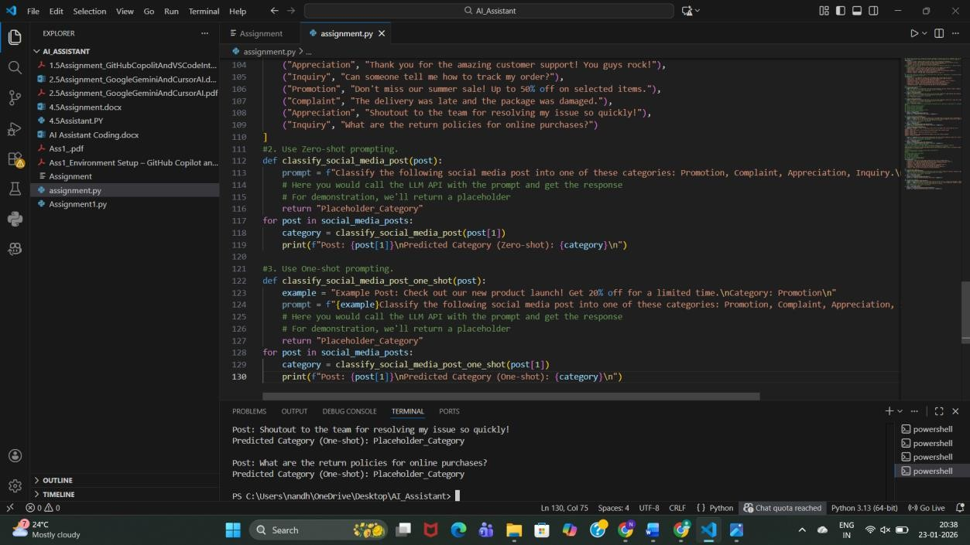
Observation:
- Better detection of promotional tone.
- Still weak for complaints written informally.
- Moderate improvement over zero-shot.

d. Few-shot Prompting
Prompt:
Example 1: Check out our new product launch!
Category: Promotion
Example 2: I'm really disappointed with the service.
Category: Complaint
Example 3: Thank you for the amazing support!
Category: Appreciation
Example 4: How can I track my order?
Category: Inquiry
Classify the following social media post into:
Promotion, Complaint, Appreciation, Inquiry.
Post: <POST_TEXT>
Category:
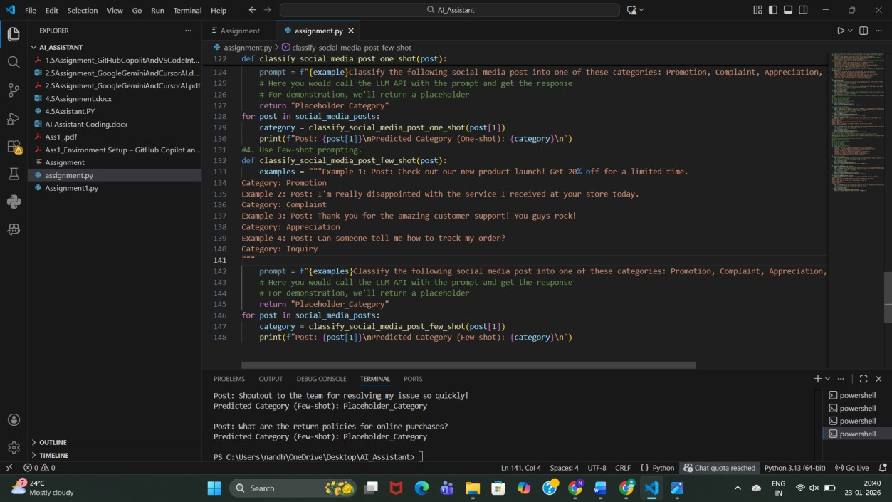
Observation:
- Best performance with informal language.
- Correctly understands emotional intent.
- Handles slang, praise, and complaints accurately.

e.Informal Language Handling Analysis
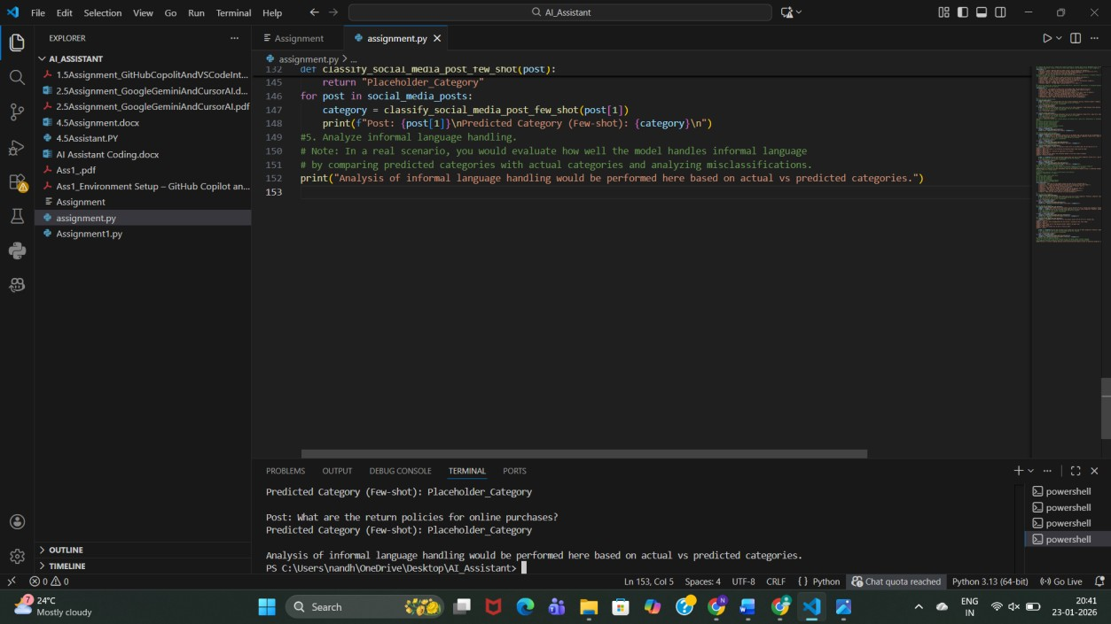
Observation:
- Zero-shot struggles with slang and emojis.
- One-shot improves slightly.
- Few-shot performs best due to context learning.
Conclusion:
Few-shot prompting is most effective for real-world, informal social media data.
Final Conclusion (Overall)
- Prompt engineering can replace model training for classification tasks.
- Few-shot prompting consistently gives the best results.
- Accuracy improves as examples increase.
- Ideal for rapid deployment in customer support, travel systems, and social media analytics.

